#Name and Student Number
#Task 1
Statistics | Value
Mean | 49.92857
Median | 54
Variance | 207.8466
Standard deviation | 14.41688
Coefficient of variance | 0.2887502
Interquartile range | 28.25

Histogram
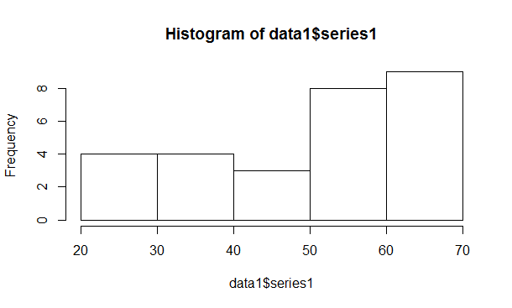

Boxplot
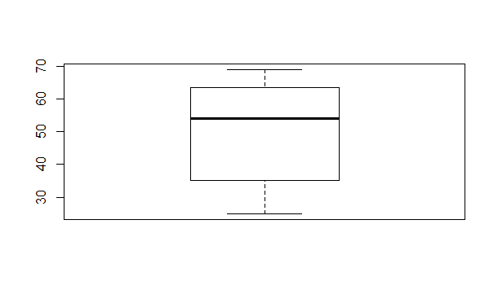
#Task 2
Statistics | Value
Mean | 33.85714
Median | 32
Variance | 123.3122
Standard deviation | 11.1046
Coefficient of variance | 0.327984
Interquartile range | 8.5

Histogram
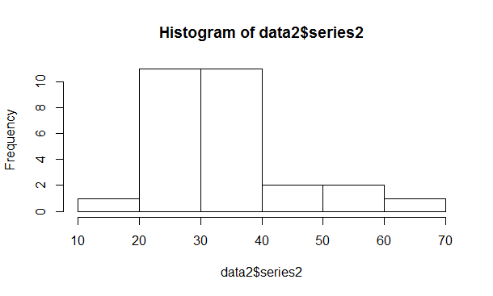
Boxplot
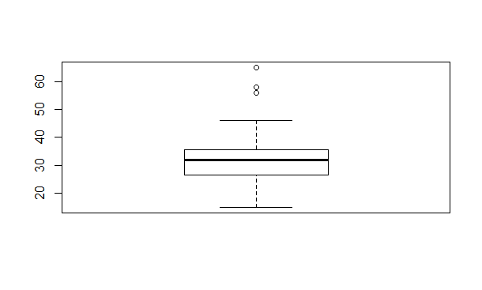
#Task 3
Statistics | Value
Mean | 47.25
Median | 47.5
Variance | 100.5648
Standard deviation | 10.0282
Coefficient of variance | 0.2122371
Interquartile range | 0.2122371

Histogram
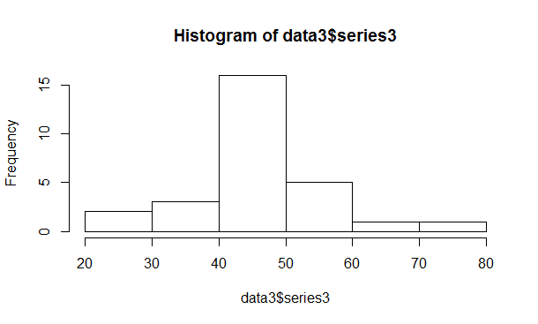
Boxplot
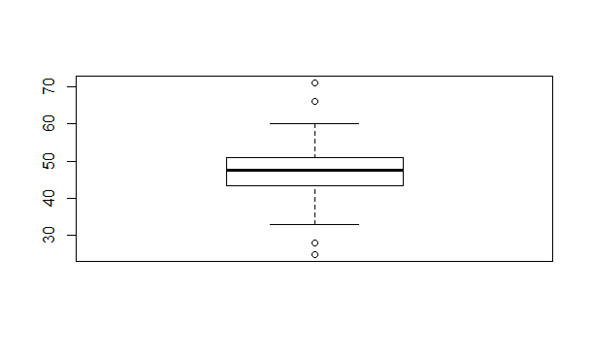

#Task 4
The boxplot below shows the percent survival rates of two species of burying beetles, Nicrophorus orbicollis and Nicrophorus pustulatus. The means show that Nicrophorus orbicollis has a higher survival rates (about 50%) than that of Nicrophorus pustulatus (approximately 10%). Moreover, Nicrophorus orbicollis, exhibits left-skew whereas Nicrophorus pustulatus depicts right-skew.
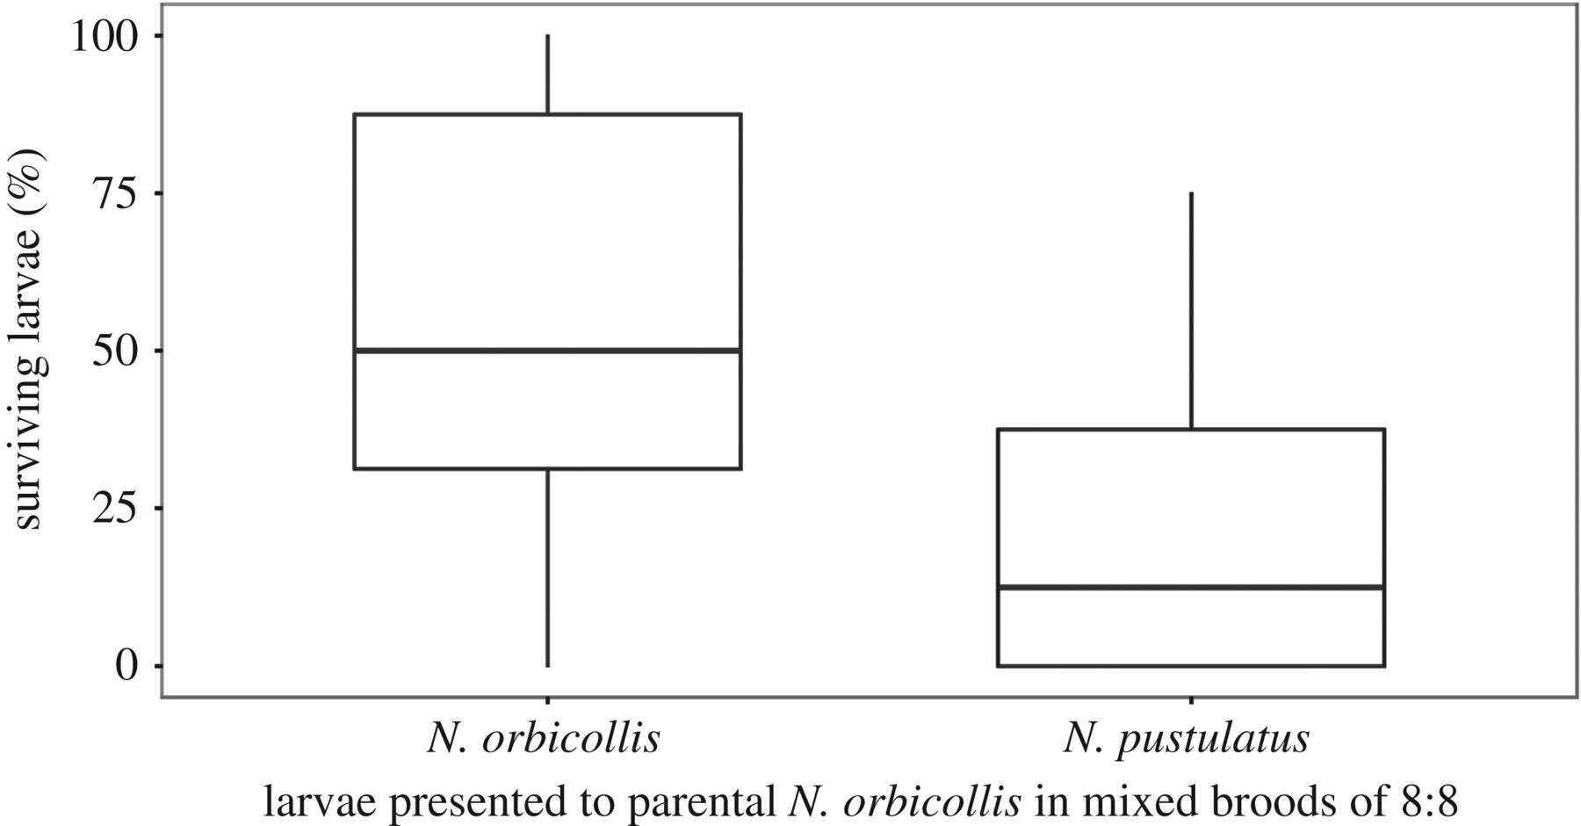

Capodeanu-Nagler, A., Torre, E.R., Eggert, A.K., Sakaluk, S.K., & Steiger, S. (2018). Divergent coevolutionary trajectories in parent-offspring interactions and discrimination against brood parasites revealed by interspecific cross-fostering. Royal Society Open Science, 5(180189), 1-12. doi:10.1098/rsos.180189. Retrieved from http://rsos.royalsocietypublishing.org/content/5/6/180189
#Task 5
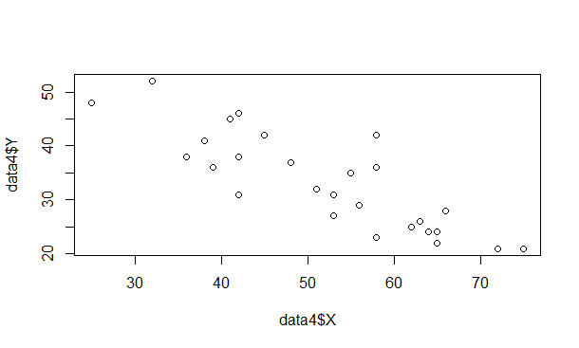
#Task 6

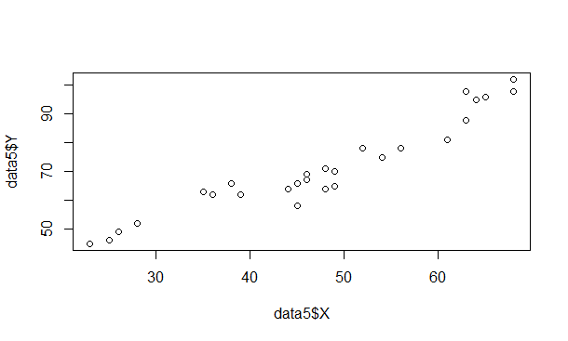
#Task 7
Mean(X) = 5
Standard deviation (X) = 3.37
Mean (Y) = 5
Standard deviation (Y) = 2.45

